**CS 628 Full-Stack Development II**

**HOS05B: Views – Other Pages**

July 19, 2020

12/29/2020 Updated by Min

School of Technology & Computing (STC)

City University of Seattle (CityU)

**Before You Start**

* The directory path shown in screenshots may be different from yours.
* Some steps are not explained in the tutorial**.** If you are not sure what to do:
  1. Consult the resources listed below.
  2. If you cannot solve the problem after a few tries, ask a TA for help.

**Resources**

* Holmes, S. & Harber, C. (2019). [Getting MEAN with Mongo, Express, Angular, and Node, Second Edition](https://login.proxy.cityu.edu/sso/skillport?context=148121). Manning Publications. (ISBN 9781617294754)
  + 4.4 Adding the Rest of the Views
* Pug, <https://pugjs.org/api/getting-started.html>

**Course Concepts**

* Understand the template engine in Express - Pug
* Understand a front-end layout framework
* Apply view templates to pages of an Express web application.

**Activities**

* Preparing for a MEAN project environment
* **Building the Details Page with location-info.pug**
* **Building the Add Review Page with location-review-form.pug**
* **Building the About Page with generic-text.pug**
* Source Code Management and Deployment

**Preparing for a MEAN project environment**

1. Copy the “module05a” directory to the “module05b” one.
2. Open the “module05b” folder in the VSCode.  
   Close the “Welcome” window.  
   Open the terminal (Ctrl+`).
3. Test whether the application works correctly.  
   >>>npm start  
     
   <http://localhost:3000>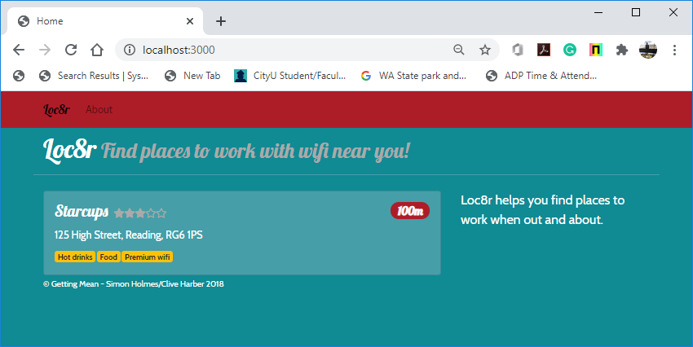

**Building the Details Page with location-info.pug**

1. Create a new view file “locations-info.pug” under the “app_server/views” directory.

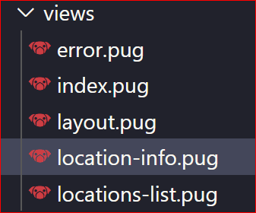

1. Tell the “locations.js” controller that you want to use this new view “locations-info.pug.”  
   Change the name of the HTML template view “index” to “location-info.”  
   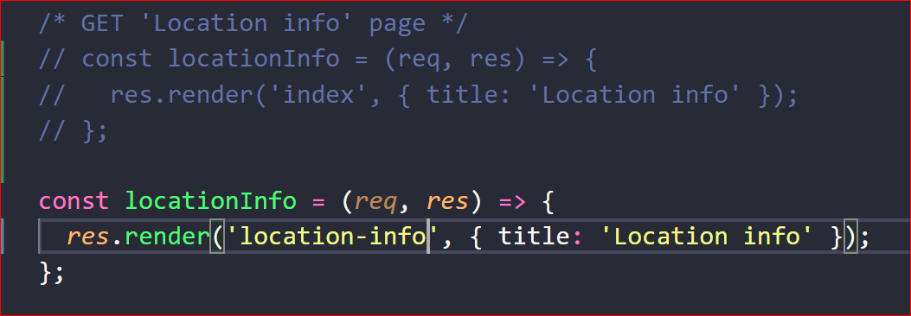
2. You will update the “locations-info.pug” HTML view template with the given Pug code.  
   This page needs to display all the information about a location, including

* Name
* Address
* Rating
* Opening hours
* Facilities
* Location map
* Reviews, each with
  + Rating
  + Reviewer name
  + Review date
  + Review text
  + Button to add a new review
  + Text to set the context of the page

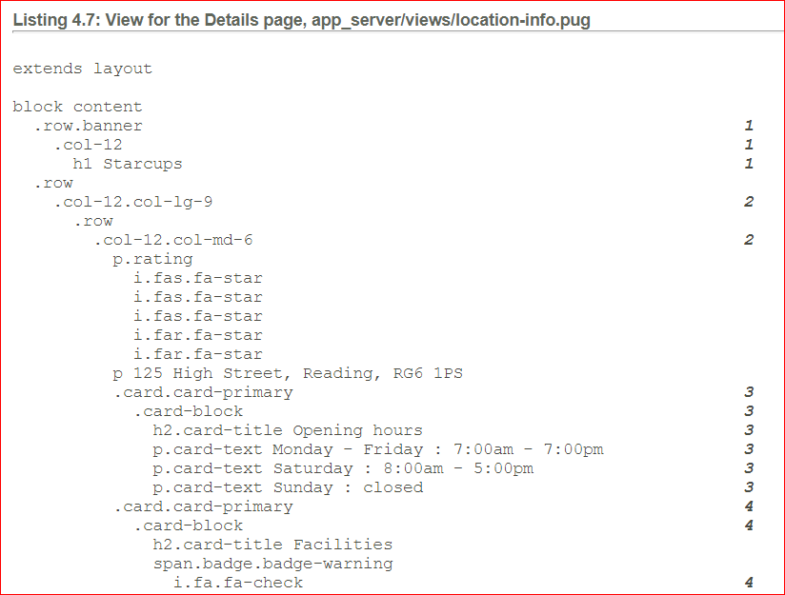

1. Run the application for testing.   
   >>>npm start  
     
   URL: localhost:3000/location/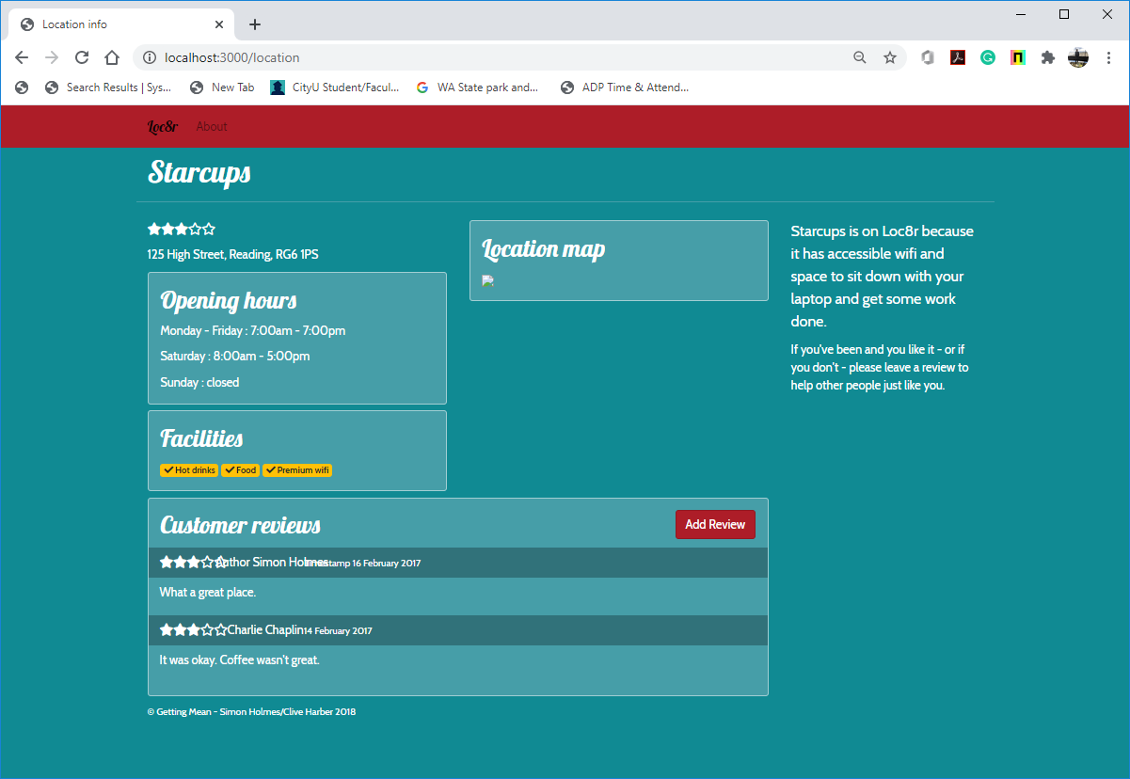

**Building the Add Review Page with location-review-form.pug**

1. Create a new view file “location-review-form.pug” under the “app_server/views” directory.

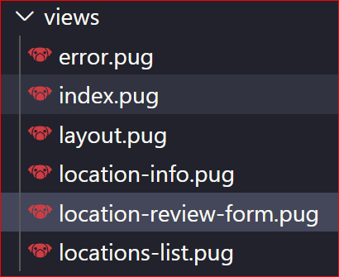

1. Tell the “locations.js” controller that you want to use this new view “locations-info.pug.”  
   Change the name of the HTML template view “index” to “location-review-form.”  
   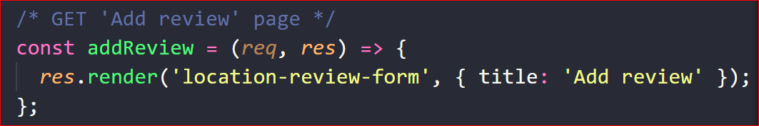
2. You will update the “location-review-form.pug” HTML view template with the given Pug code.  
   This page holds a form that contains the user's name and a couple of input fields for the rating and review.

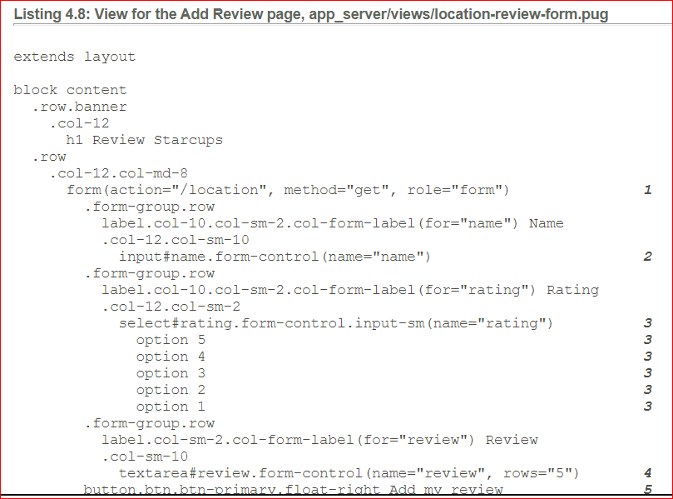

1. Run the application for testing.   
   >>>npm start  
     
   URL: localhost:3000/location/review/new  
   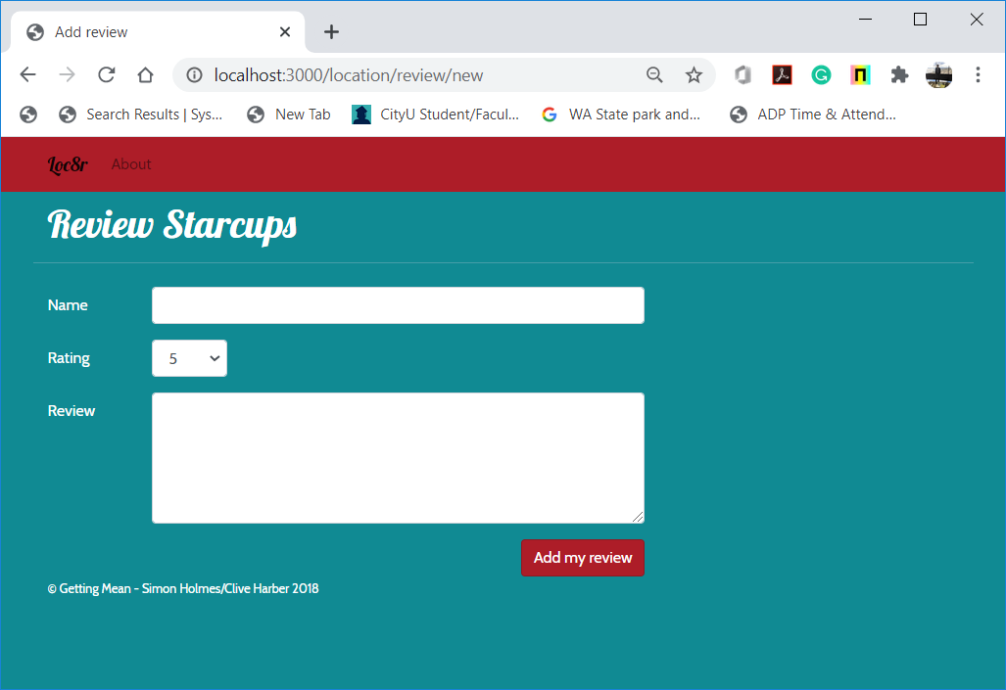

**Building the About Page with generic-text.pug**

1. Create a new view file “generic-text.pug” under the “app_server/views” directory.

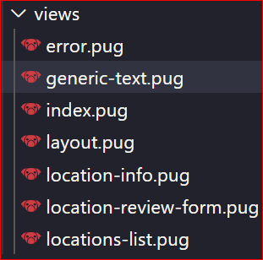

1. Tell the “others.js” controller that you want to use this new view “generic-text.pug.”  
   Change the name of the HTML template view “index” to “generic-text.”  
   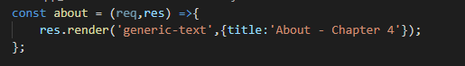
2. You will update the “generic-text.pug” HTML view template with the given Pug code.  
   This page has a header and some content.

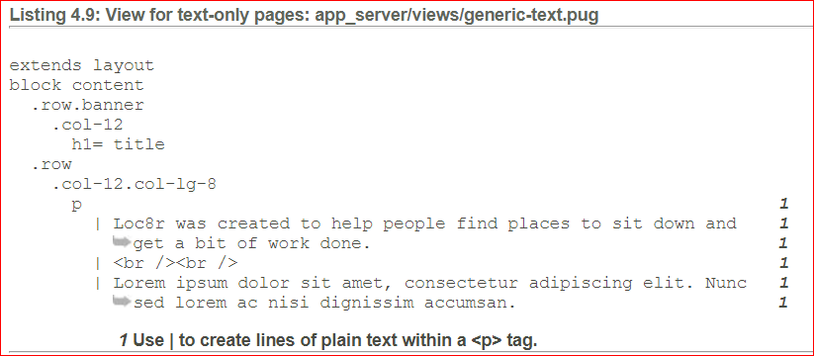

1. Run the application for testing.   
   >>>npm start  
     
   URL: localhost:3000/about  
   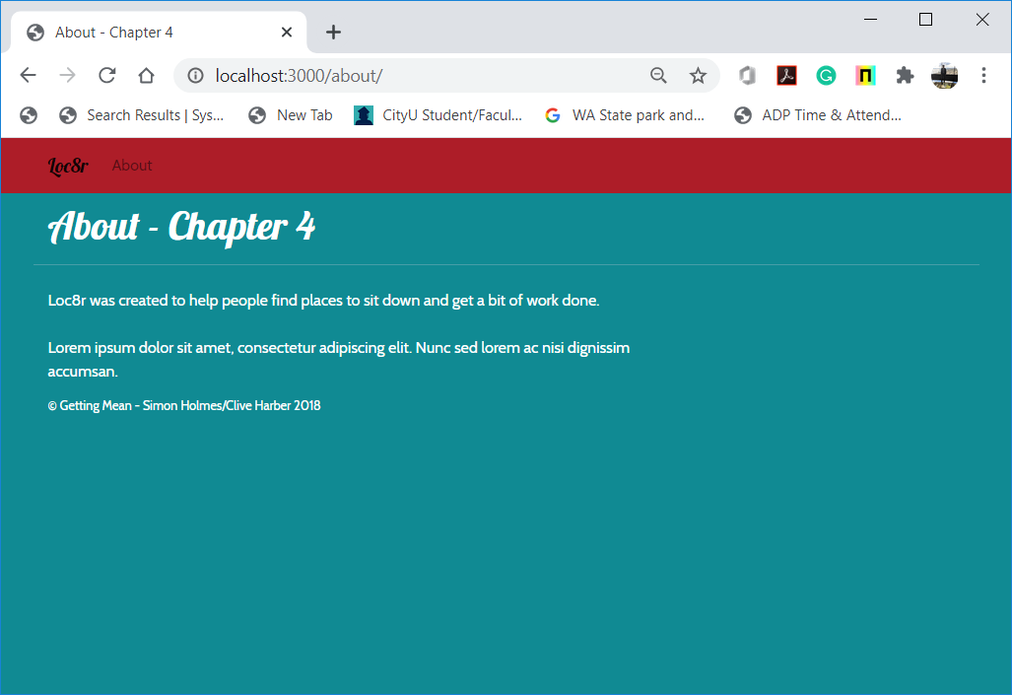

**Source Code Management and Deployment**

**Push your work to GitHub**

Run the following commands to push your work to the GitHub repository:

Open the terminal from the VSCode by hitting the control + ~ key and type the following command:

>>> git add .

>>> git commit -m “Submission for Module 5B --yourname”

>>> git push origin master

**Push your work to Heroku**

>>> git push heroku master

If you cannot remember your branch name, run the command “git status” to check.